Updating and adding content to the webpage

Adding a logo

Image/logo sizing
The logo box size is 120px high and wide so the image should be larger than this and be of equal dimensions (200px by 200px).
The image should not be larger than 1000px wide and tall as it will take a long time to load the image when someone accesses the website.

Image/Logo File
The image file needs to be saved in the Images folder for the website with a simple name e.g. “Logo19_04_2022”.

Adding the new logo to the website
Open up the website project using Atom and connect your remote FTP.
Right click the Images folder on the left tab and upload it, then open the layout.html file.
Under the Header section you will find the following code: <h1 class="logo"><img src="images/xxx" alt"IMG not working"></h1>. The xxx is the name of the image file including its image type (png, jpg, etc) and is what you will need to change to get the new logo working.
Replace what is currently xxx and put in the name of the image file e.g. Logo19_04_2022.png.
Save the layout.html file and upload it. Upon refreshing the website, the new logo should appear where the original was.

Changing the main page heading

Opening and locating the code
Open up the website project using Atom and connect your remote FTP. Open up the layout.html file.
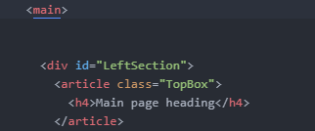
Scroll down and under the Main section you will see two <div> blocks. In the first <div> with the id LeftSection you will see an <h4>XXXX</h4>.
This is the page heading code with XXXX being the heading shown on the website.

Changing the heading
Change the XXXX to the new page heading.
Save the layout.html file and upload it. Upon refreshing the website, the new heading will appear.

Adding/modifying the main page content

Opening and locating the code
Open up the website project using Atom and connect your remote FTP. Open up the layout.html file.
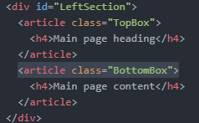
Scroll down and under the Main section you will see two <div> blocks. In the first <div> with the id LeftSection you will see the following code:

NOTE: All changes must be between <article class="BottomBox"> and the corresponding </article>.

Heading of the main page content box
The <h4>XXXX</h4> is a heading for the content box, change the XXXX and it will change the heading.

Adding and removing articles
To add an article first create a space below the heading line and write article and press TAB. This will create an article block.
To remove, delete the <article class="">, </article> and everything between.

Adding content to the box
Under your new article create a new paragraph with <p> </p>. Place the content in between, creating a new <p> </p> for each paragraph.

